Fabulous English lessons. First pack.
Description:
In this teaching package, you will find efficient help for early English language learning. The interwoven stories and related activities introduce children to the mysteries of the language in a new way. Each pack contains a tale the children can work on the words and knowledge they hear in the story through activity sheets and movement games in math, reading, writing, environment, and art while developing a range of skills. The pack also includes a set of different flashcards for each story. The method is designed for a group of children who participate in game-based development twice a week. Each pack is suitable for individual or group language development. They can be used independently of each other.
The stories and the linked activities help to refine emotional and moral competencies and develop a good self-esteem. Tales are focus on equality, open communication, and helping each other. Our series of environmental stories illustrate ecological problems and the importance of nature conservation. At the end of each story, you'll find a fun fact that provides children some interesting information.
1 pack: Introductions
Introductory activities, worksheets, games:
* Parent and child pairing with one line (emotional Edu, pencil control)
* Pairing arctic animals and their shadows with coloring
(following multi-step directions)
* Differentiating by size using circles (math skills)
* What does not belong there? (establishing an environmental mindset, decision-making)
* Letter tracing (motor control and handwriting)
* Movement game (gross motor skills)
* Picture sequence (recognize patterns, develop reading comprehension)
* Mind map (visual thinking, organizing knowledge)
more to come:
2. package: Words close to children.
3. package: Colors
4. package: Counting
5. package: Forest animals
6. package: Seasons/ Autumn
etc.

"Learn English with the magic of our tales!"
Our stories are structured to allow learning two languages at the same time. In this format, stories and exercises are available in the two languages of your choice.
The language packs currently available are English-Hungarian, English-Spanish, English-Chinese.)
You can find out more about these special packages, ask questions and order them here:
www.mesesangolosok.com

MESÉS ANGOLOSOK / FABULOUS ENGLISH
LUKÁCS KATA / MATA GABI

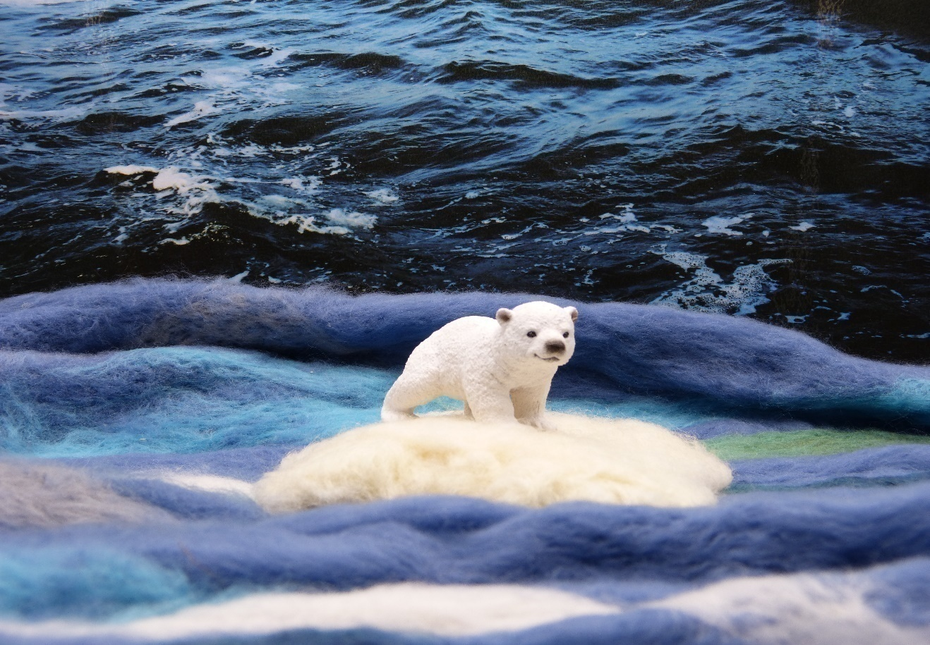

SNOWBALL THE LITTLE POLARBEAR
/First tale/

Snowball the little polar bear

In the far Arctic, where in the old times snow and ice never melt, a polar bear mom lived with her little cub at the foot of the largest iceberg. His name was Snowball.
Snowball loved to play. He and his mother went out to snowball, and build a snow bear. One day, while they were playing outside, they caught sight of seals on the edge of the ice. Snowball saw the seal kids chasing and playing together. He also wanted to catch them, but as he got closer to them, all the seals ran into the water. Snowball was very sad. He wanted to play with kids. He also asked her mom why he didn't have someone to play with? His mom told him that there were many more polar bears in the area in the past, but as the Arctic ice began to melt, fewer and fewer became. At the foot of other icebergs, polar bears are sure to live, but he has also heard that far – far away, where the trees thicken into forests, some bears have not white but brown fur.

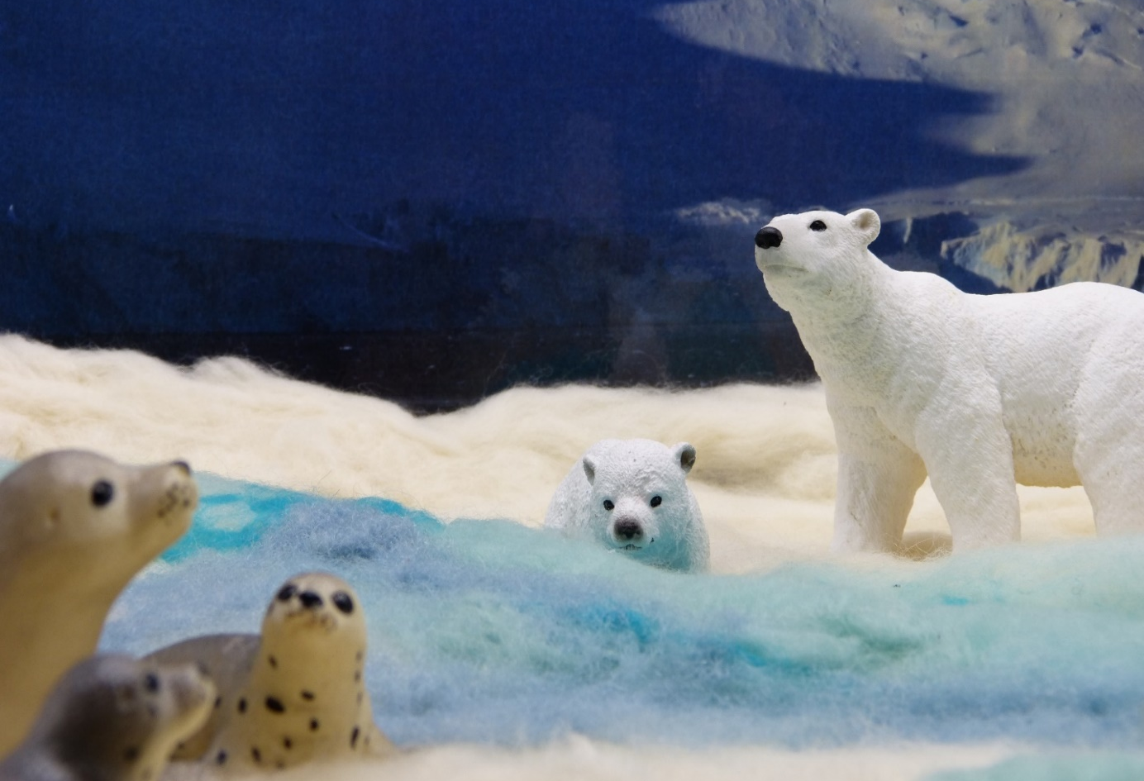

Snowball decided to find a friend for himself. The next day, he jumped on a large ice floe. The ice floated on the sea. Snowball was watching where he would see polar bears. As he swam past an iceberg, he occasionally met polar bears but did not meet any little bears.
The wind intensified. The ice floe on which Snowball was travelling was swimming much faster than before. Snowball scared. He was drifting farther away from the iceberg where he was living with his mom.
- Oh, oh, what about me now? Where does the sea take me? How do I get home to my mom? I don't even have a friend !!!

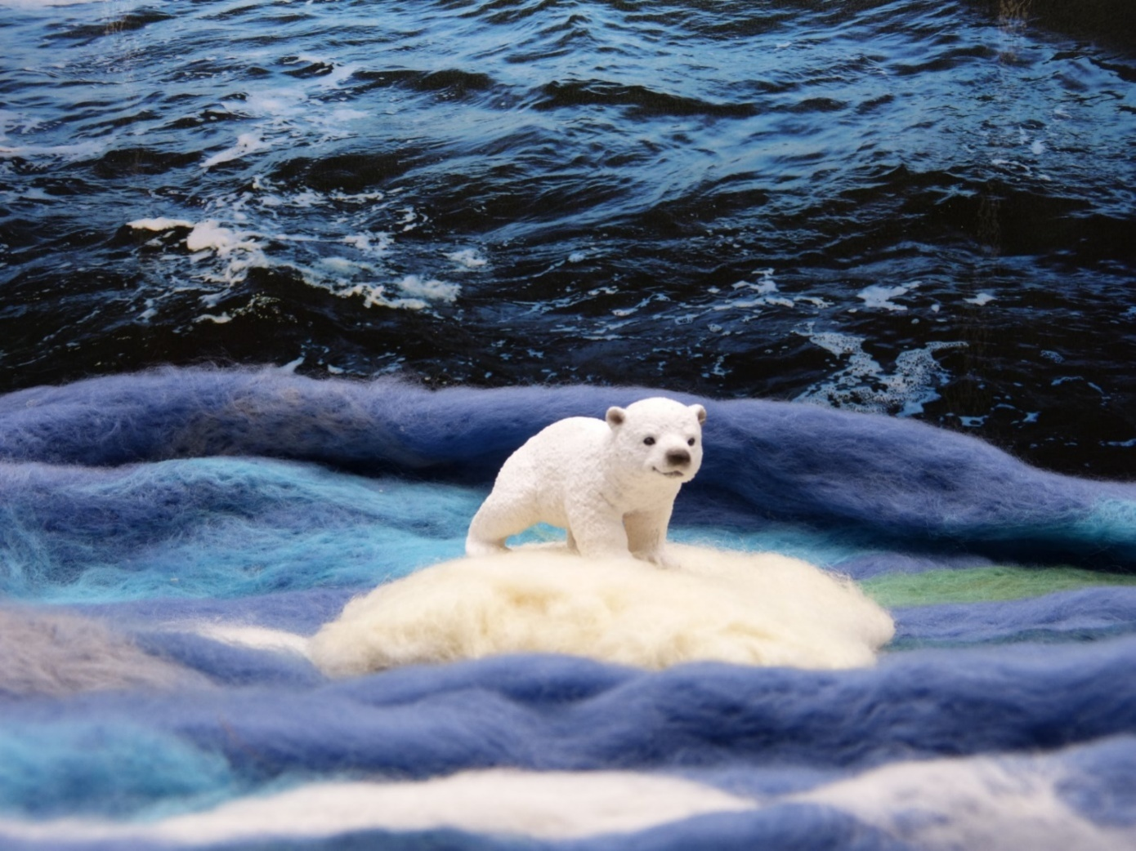

The ice floe just swam, swam in the sea, but not only did it swim but it was getting smaller. The wind blew Snowball's ice foe, where it was getting warmer. And in the heat, we already know that the ice is starting to melt. This was the case with Snowball's ice floe. The little polar bear was more and more scared. The ice floe had become so small that only Snowballs four paw could fit on it. Then, as he looked around, he saw huge trees rising before him.

The ice floe landed. Snowball jumped down from it.

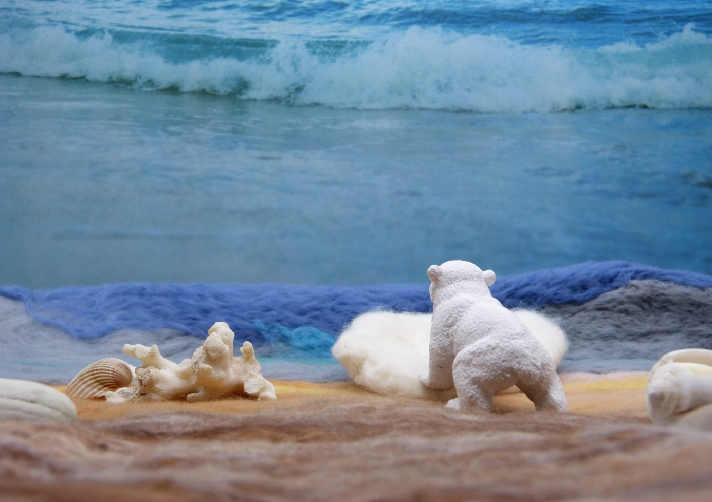

He set off for the trees on the beach. As he entered the forest, strange smells hit his nose. He had never felt such a thing. Sweet and sour. You know this fine forest scent. Snowball suddenly heard familiar voices. Something like that:
-Brum, Brum, Brum, Brum. It wasn't as deep as his mom's, but similar. He ventured further.
The trees were thinning and Snowball came to a clearing where he saw a bear exactly the same size as himself.

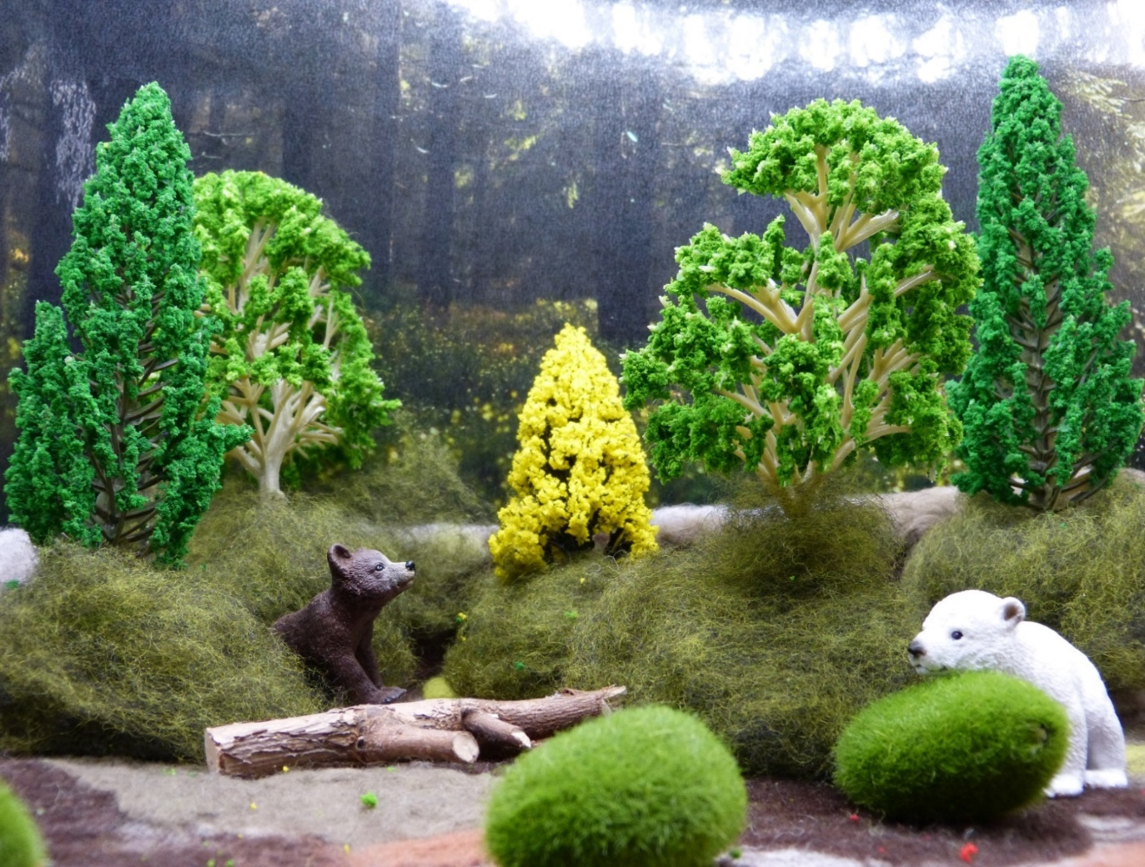

- It is a bear!- Snowball sighed. He looked down at his paw, glanced up at the other bear.
- Well, he's not like me! Not a white coat, but brown! Well, that's what my mom told me about it!
By the time Snowball was thinking about it, the brown bear sensed that someone was watching him. He looked around and saw the polar bear cub at the edge of the clearing. He jumped back because he had never seen a bear with a white coat.
Then they carefully moved closer to each other. Snowball spoke first.
- Hi, my name is Snowball, a little polar bear. I am looking for friends. What is your name?
- My name is Brownie, a grizzly cub. If I grow up, I will be a huge bear!
- Will we be friends? I want to play with you!

- Okay, let's be friends!- said Brownie and the two little bears jumped and bounced happily on the clearing.

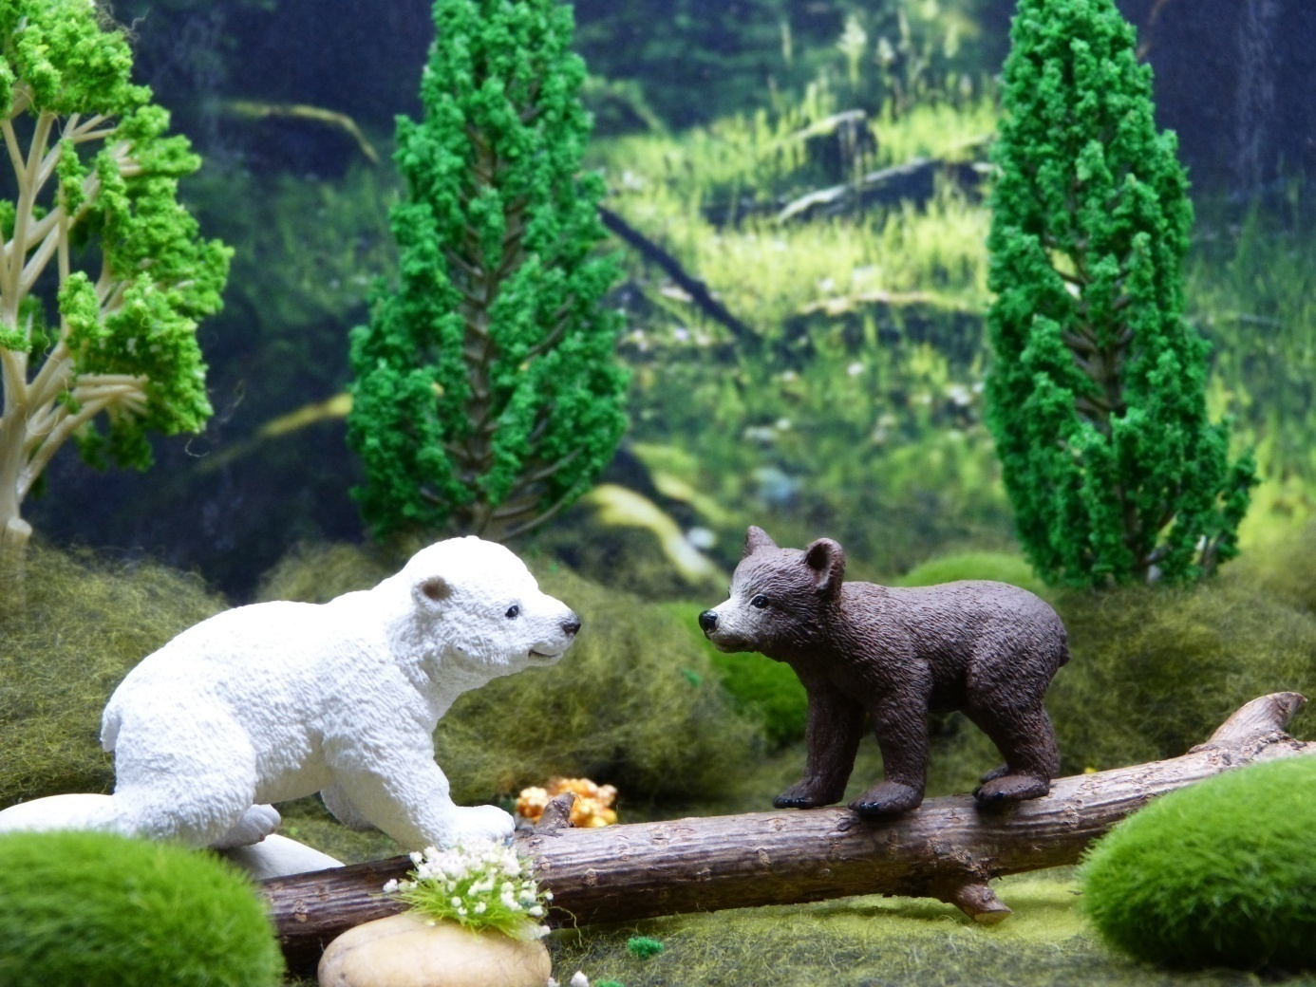

This is how the friendship between Brownie and Snowball began.

End of the first tale! We hope, you enjoyed it! Now scroll down and do the playful tasks! Let the fun begin!

Little science for the smart:
Pizzly or grolar? Icerizzly? Maybe a grizzly polar bear? Researchers have given a number of nicknames to the strange hybrid that is popping up in more and more places today and has no official name yet. Due to the warming of their environment, grizzlies living in Alaska and Canada are migrating north, where they are increasingly mating with polar bears living there.

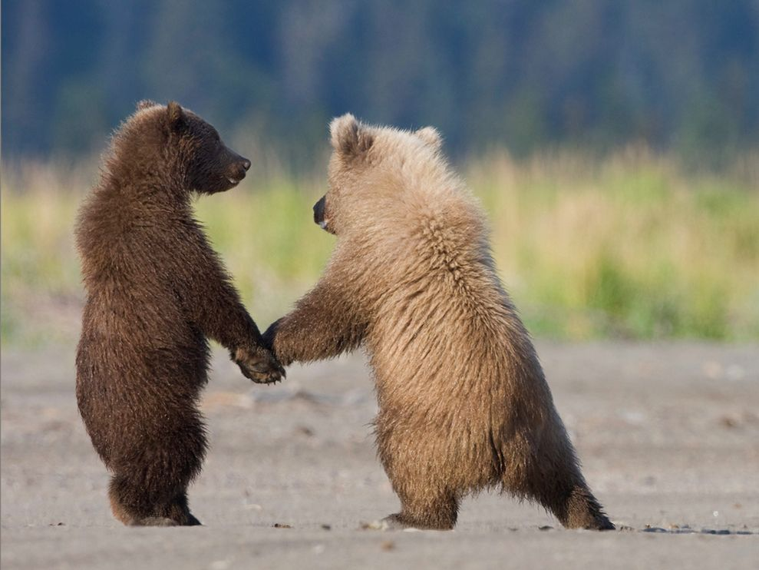

Snowball’s Dictionary

/The words ont he flashcards/
    - snow
    - ice
    - polar bear
    - Snowball
    - ice floe
    - seal
    - sea
    - wind
    - bear
    - white
    - brown
    - What is your name?
    - My name is..
    - Brownie
    - a grizzly bear cub

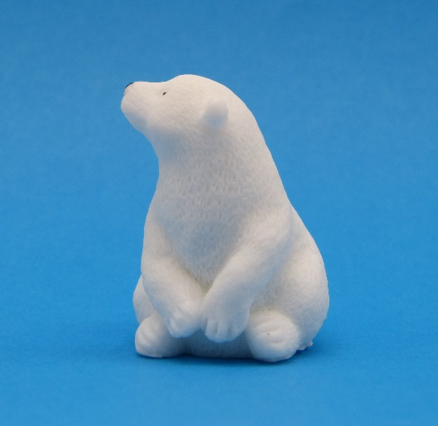

The flashcard set:

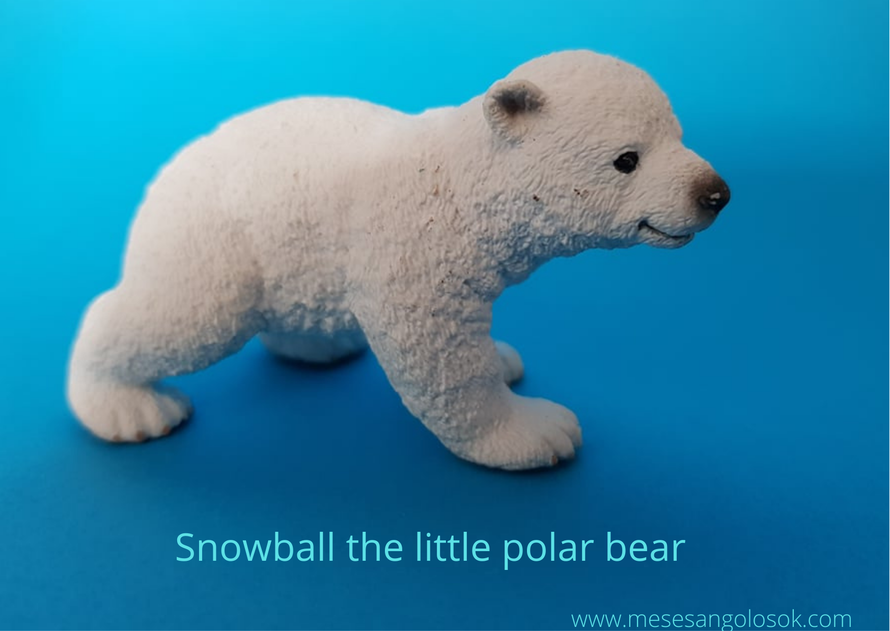

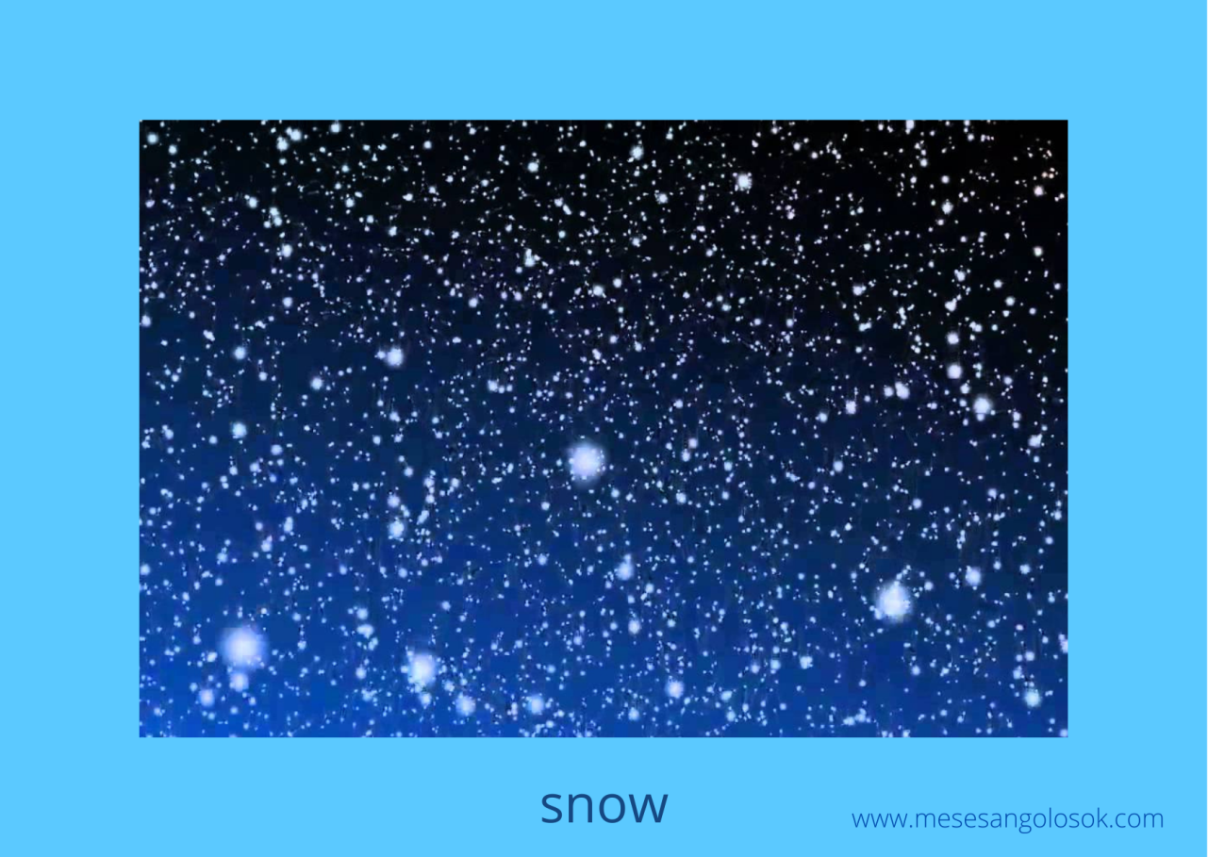

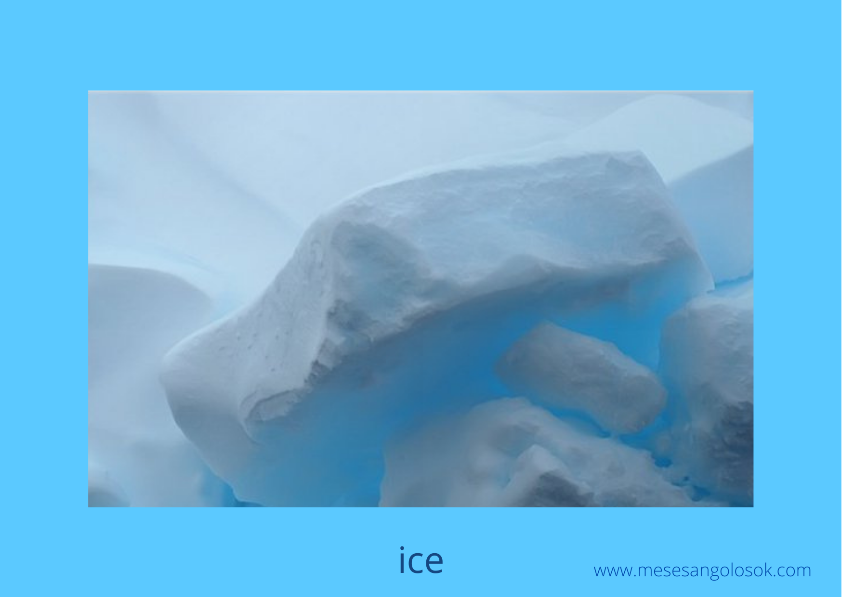

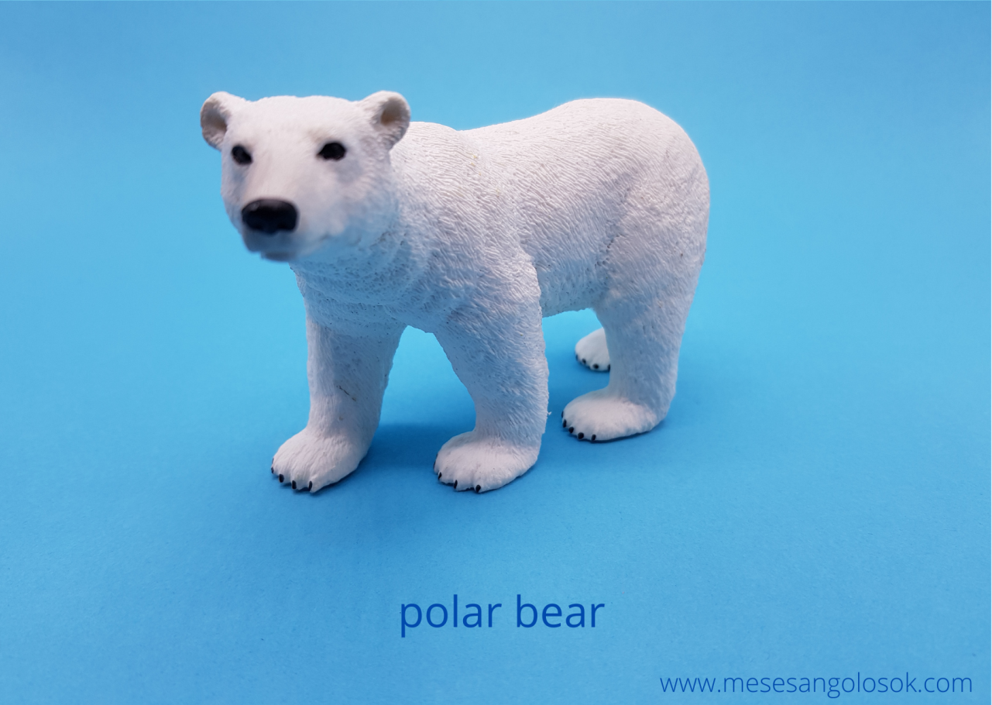

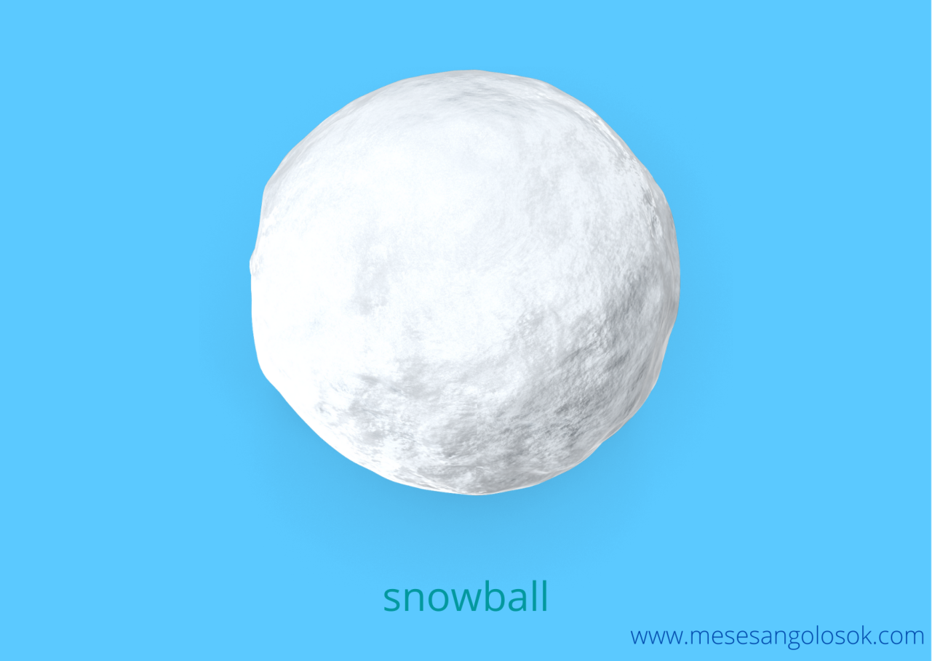

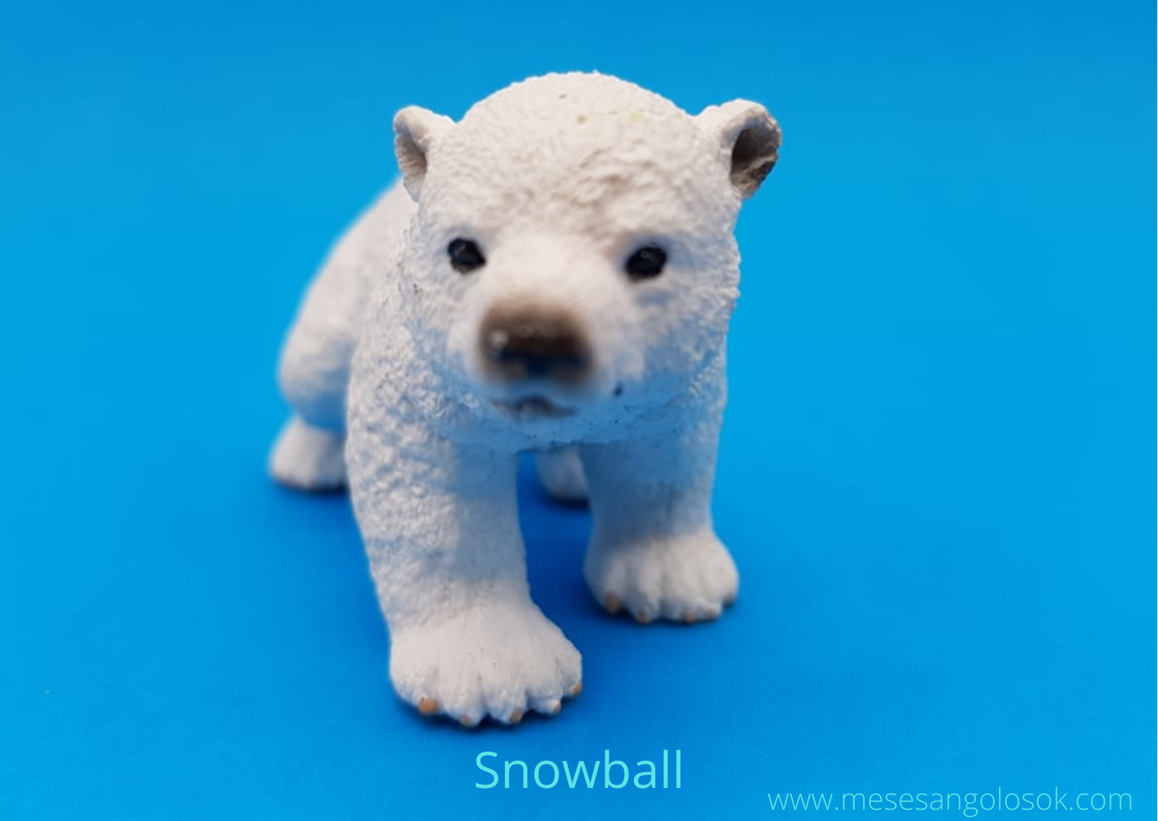

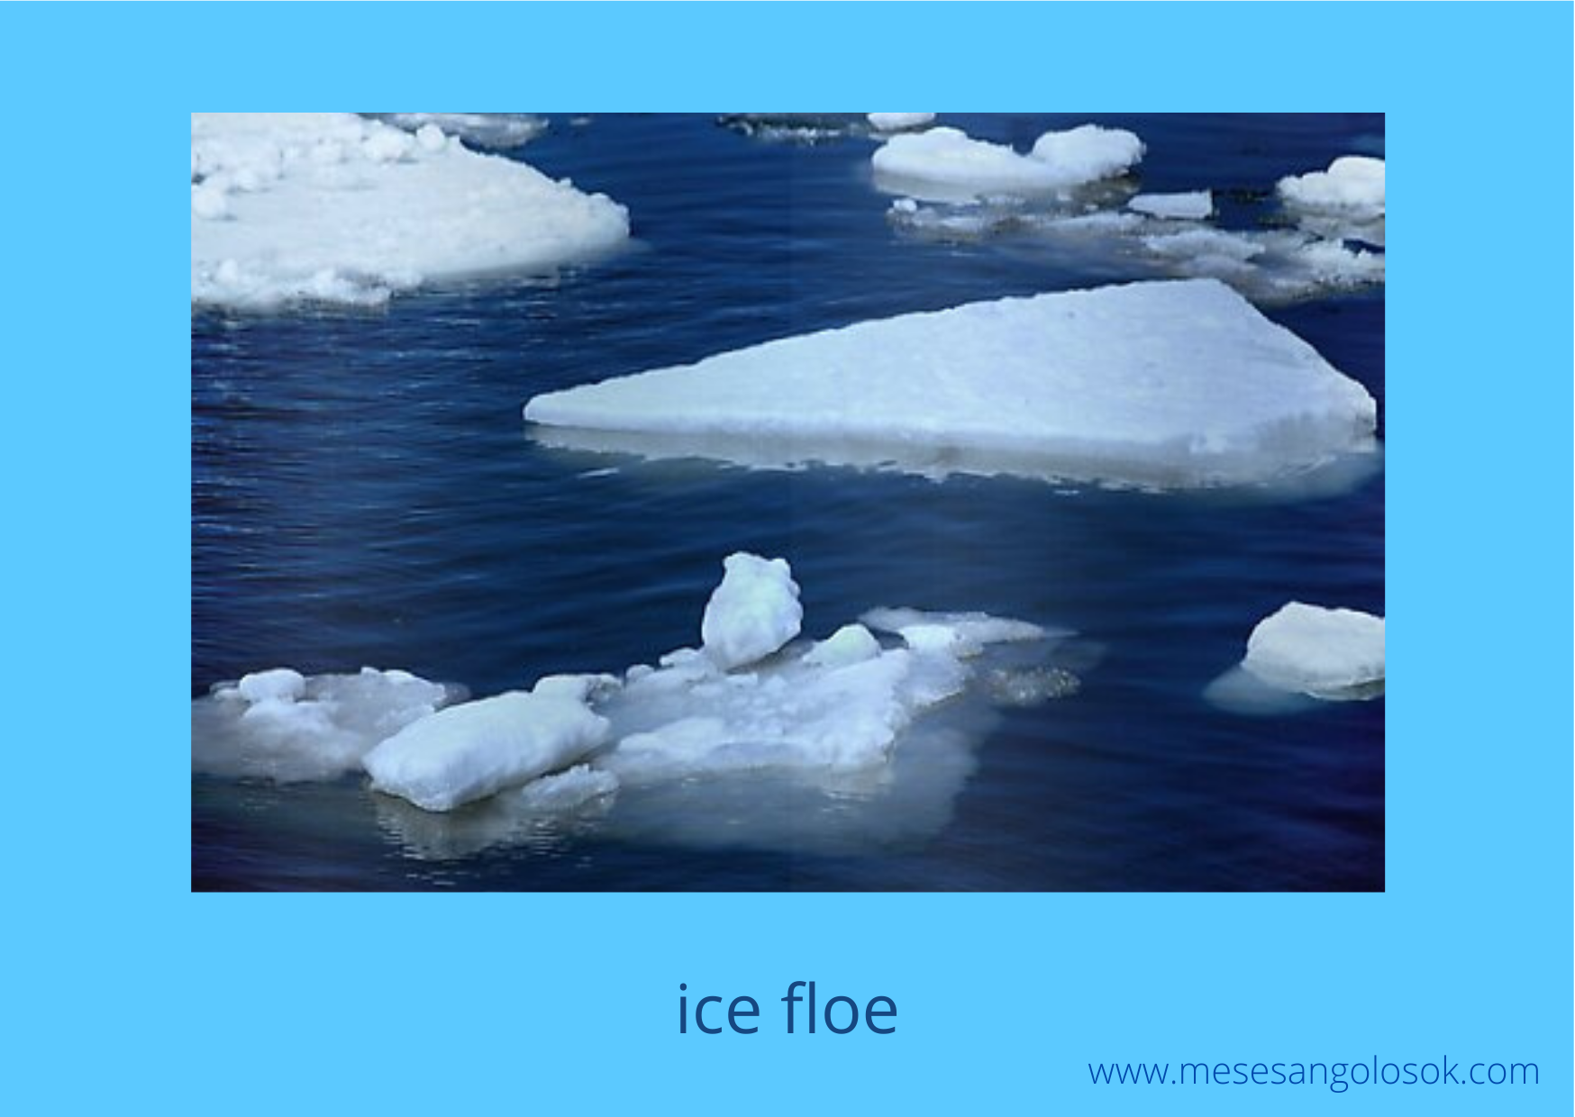

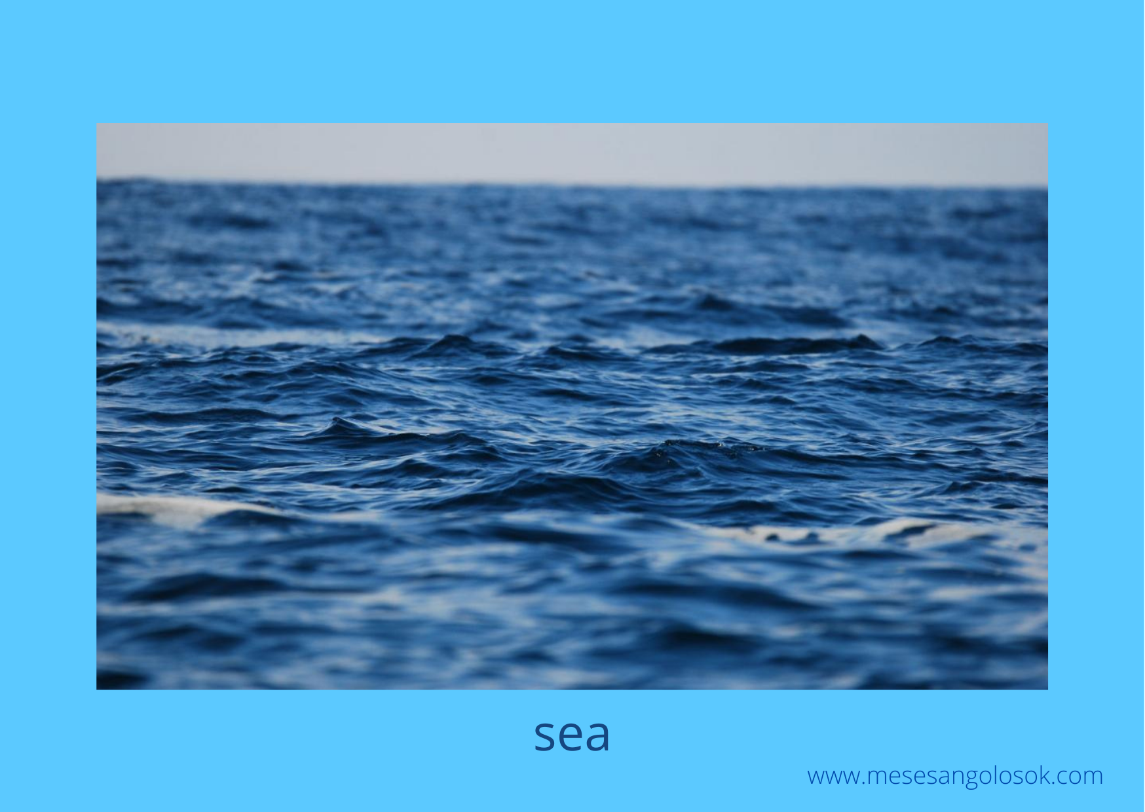

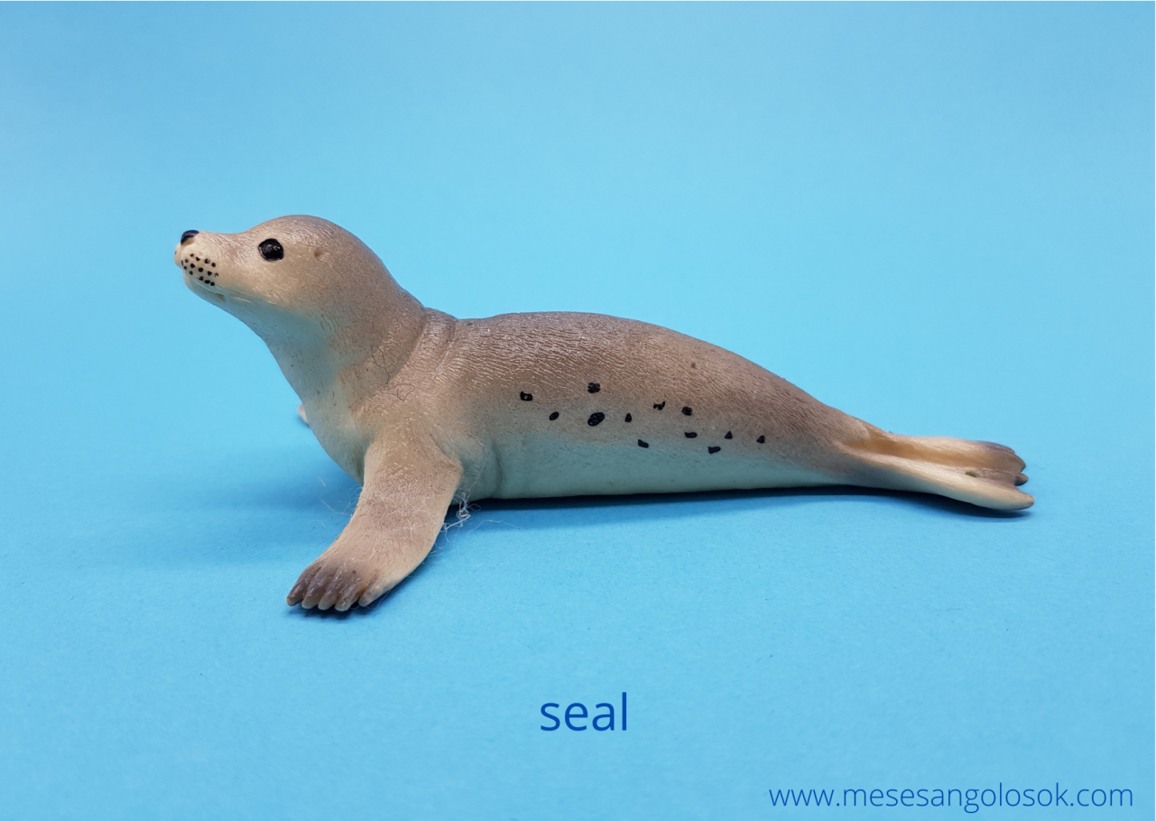

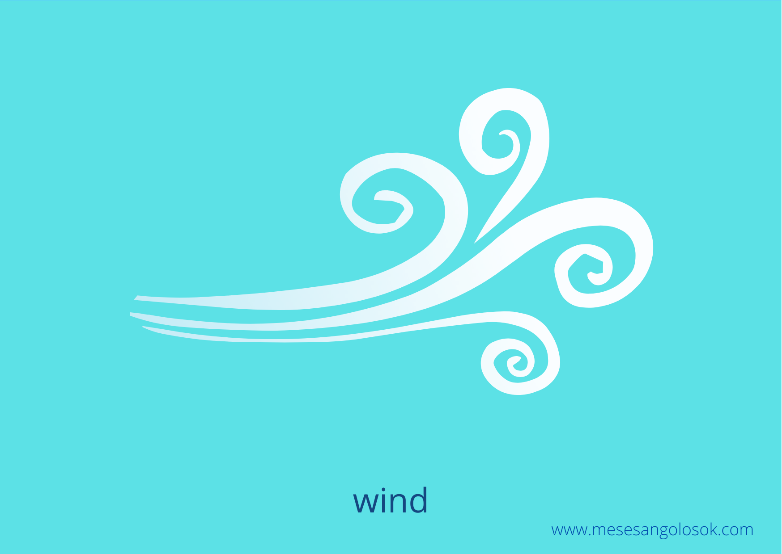

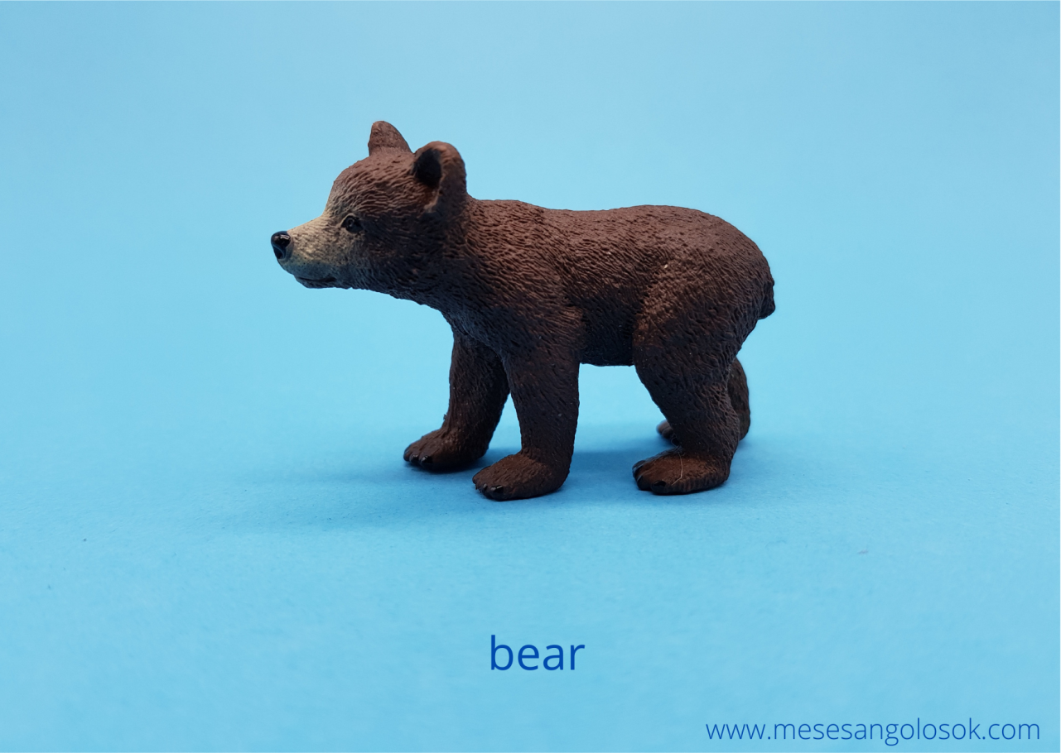

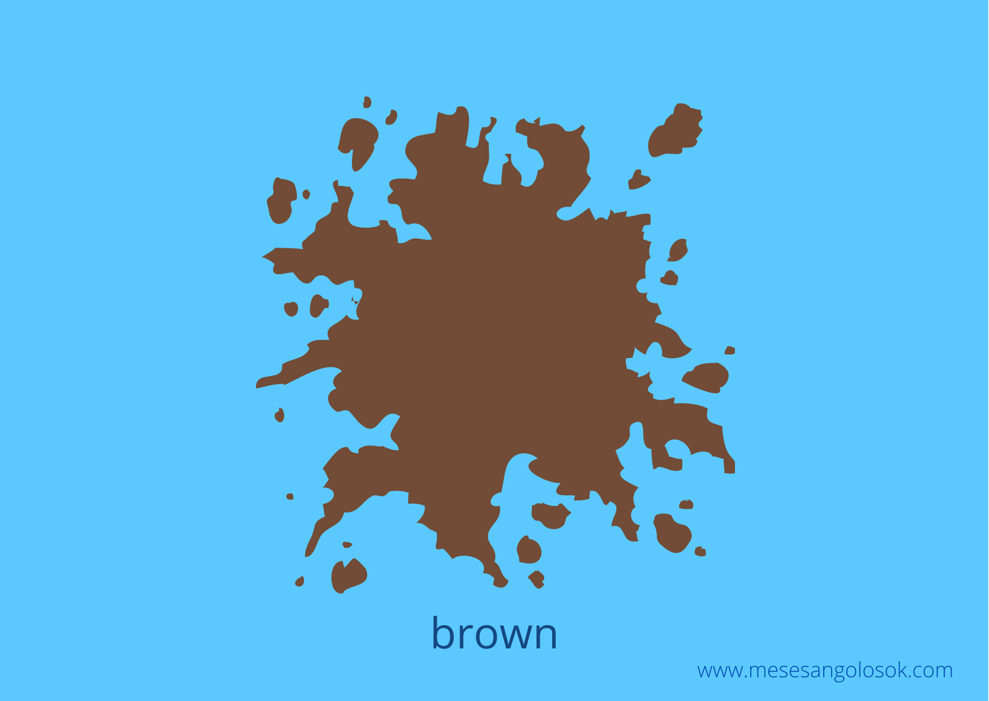

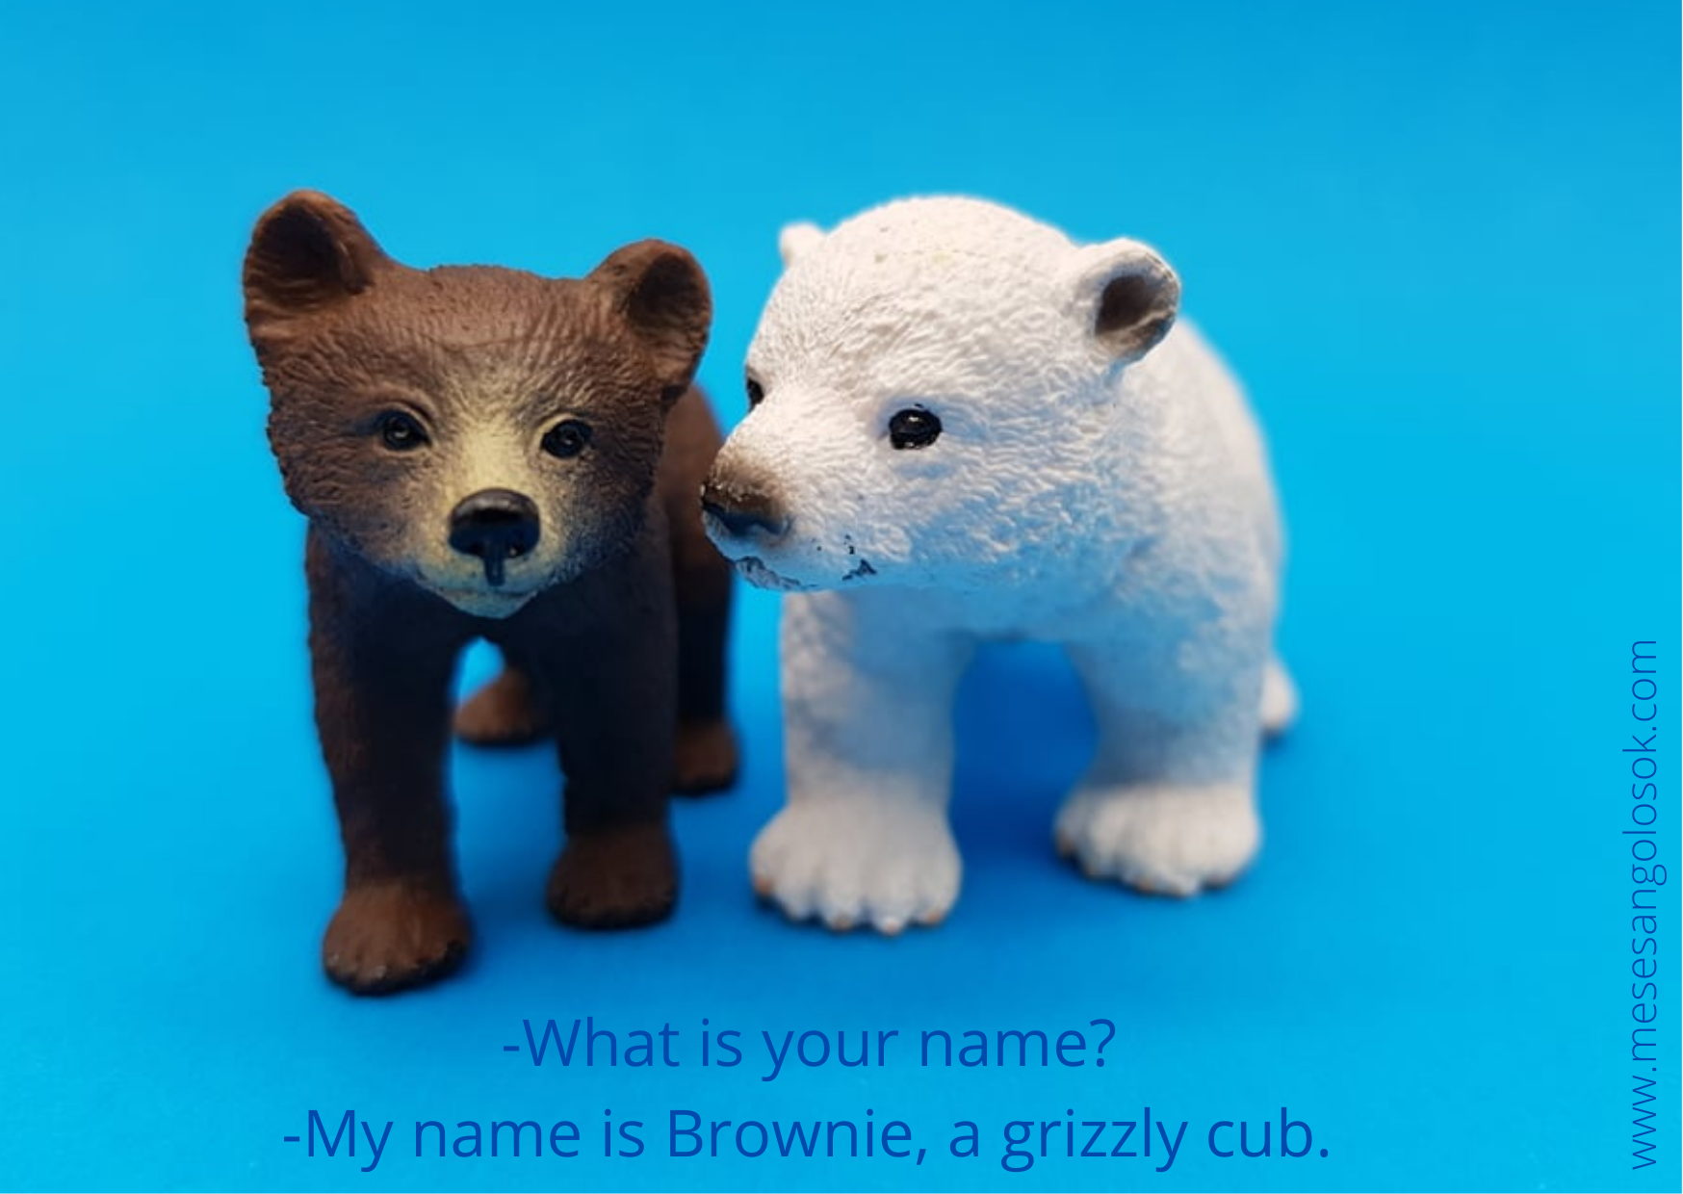

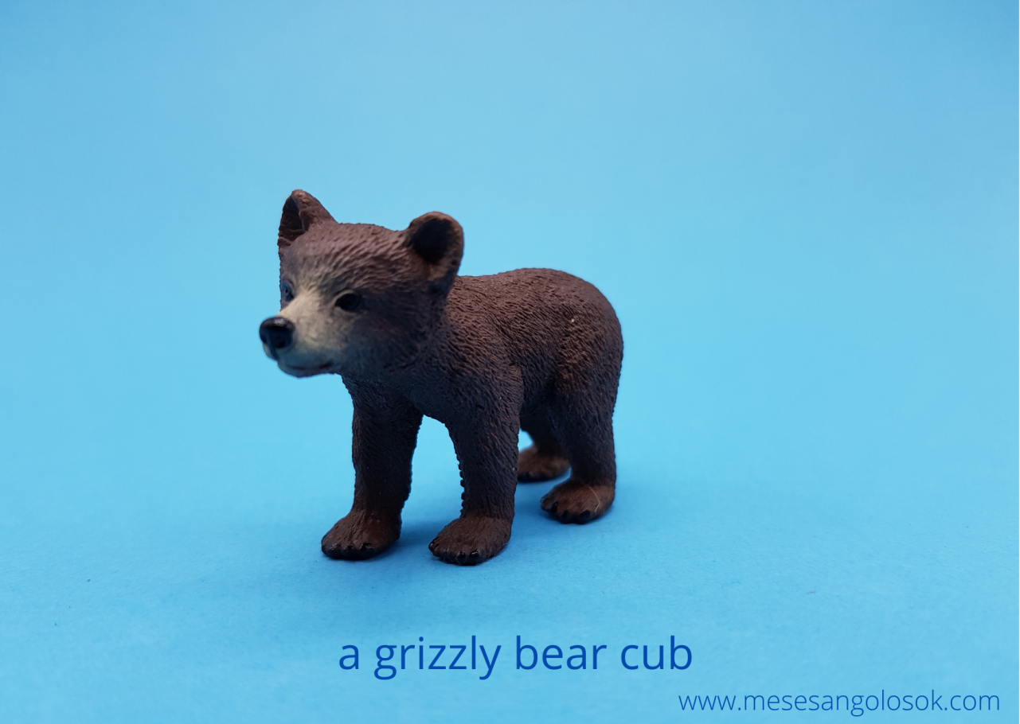

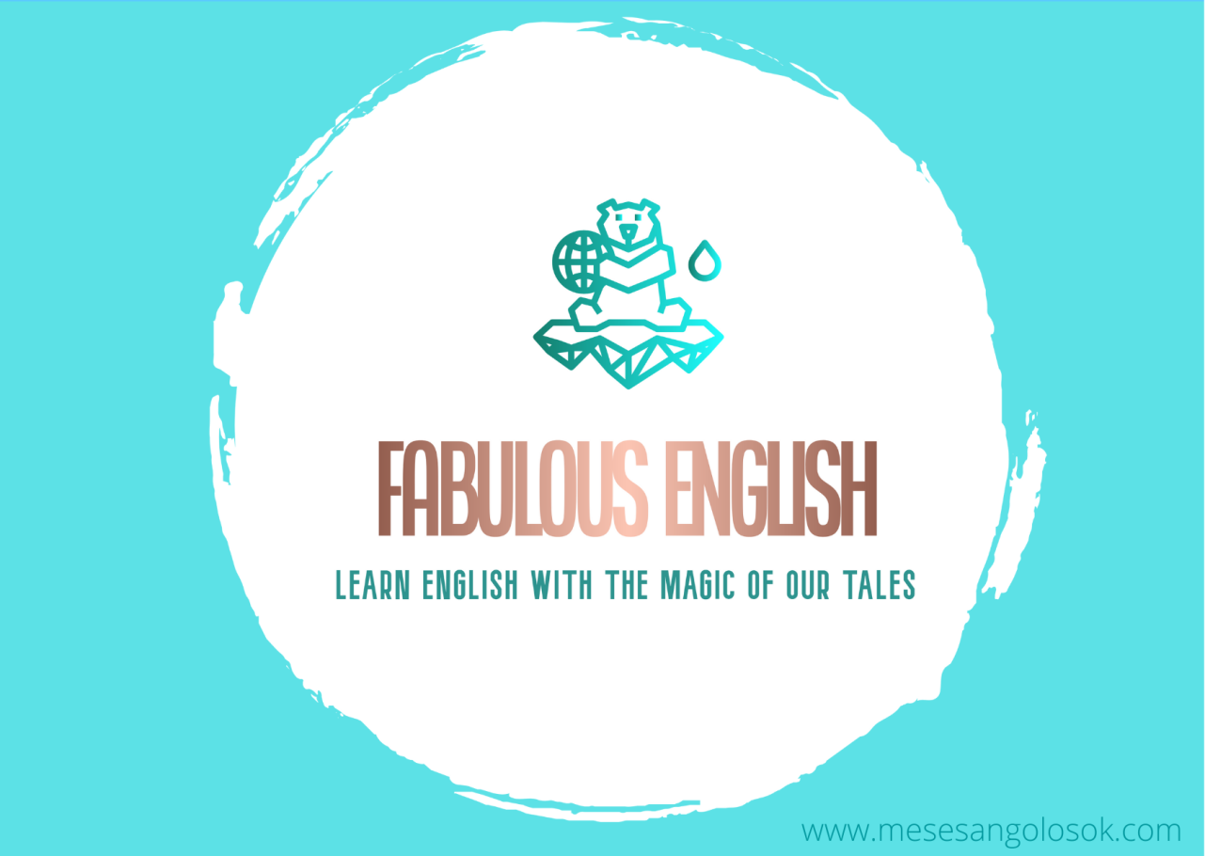

The Worksheets:

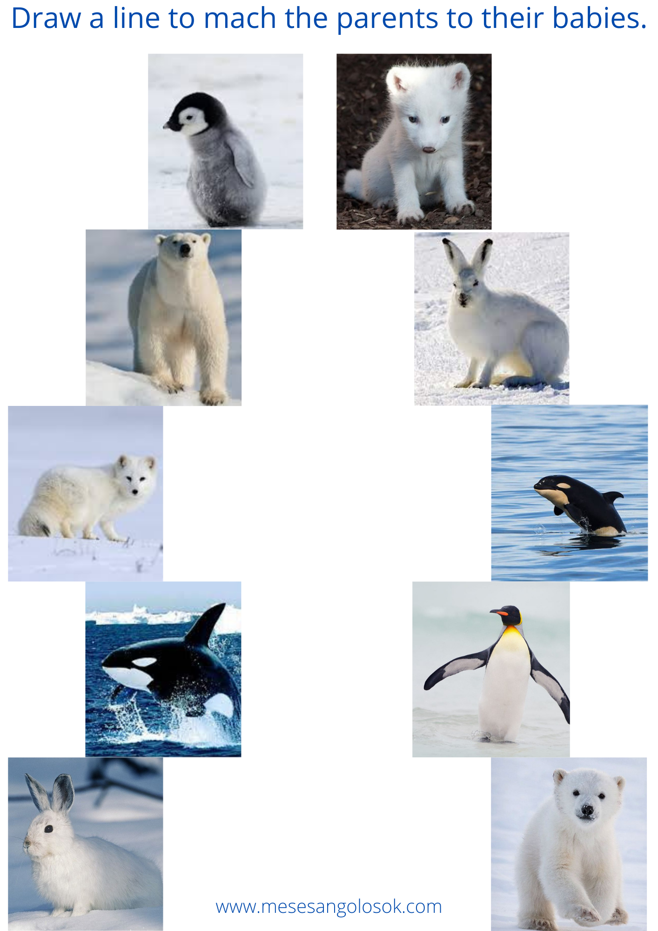

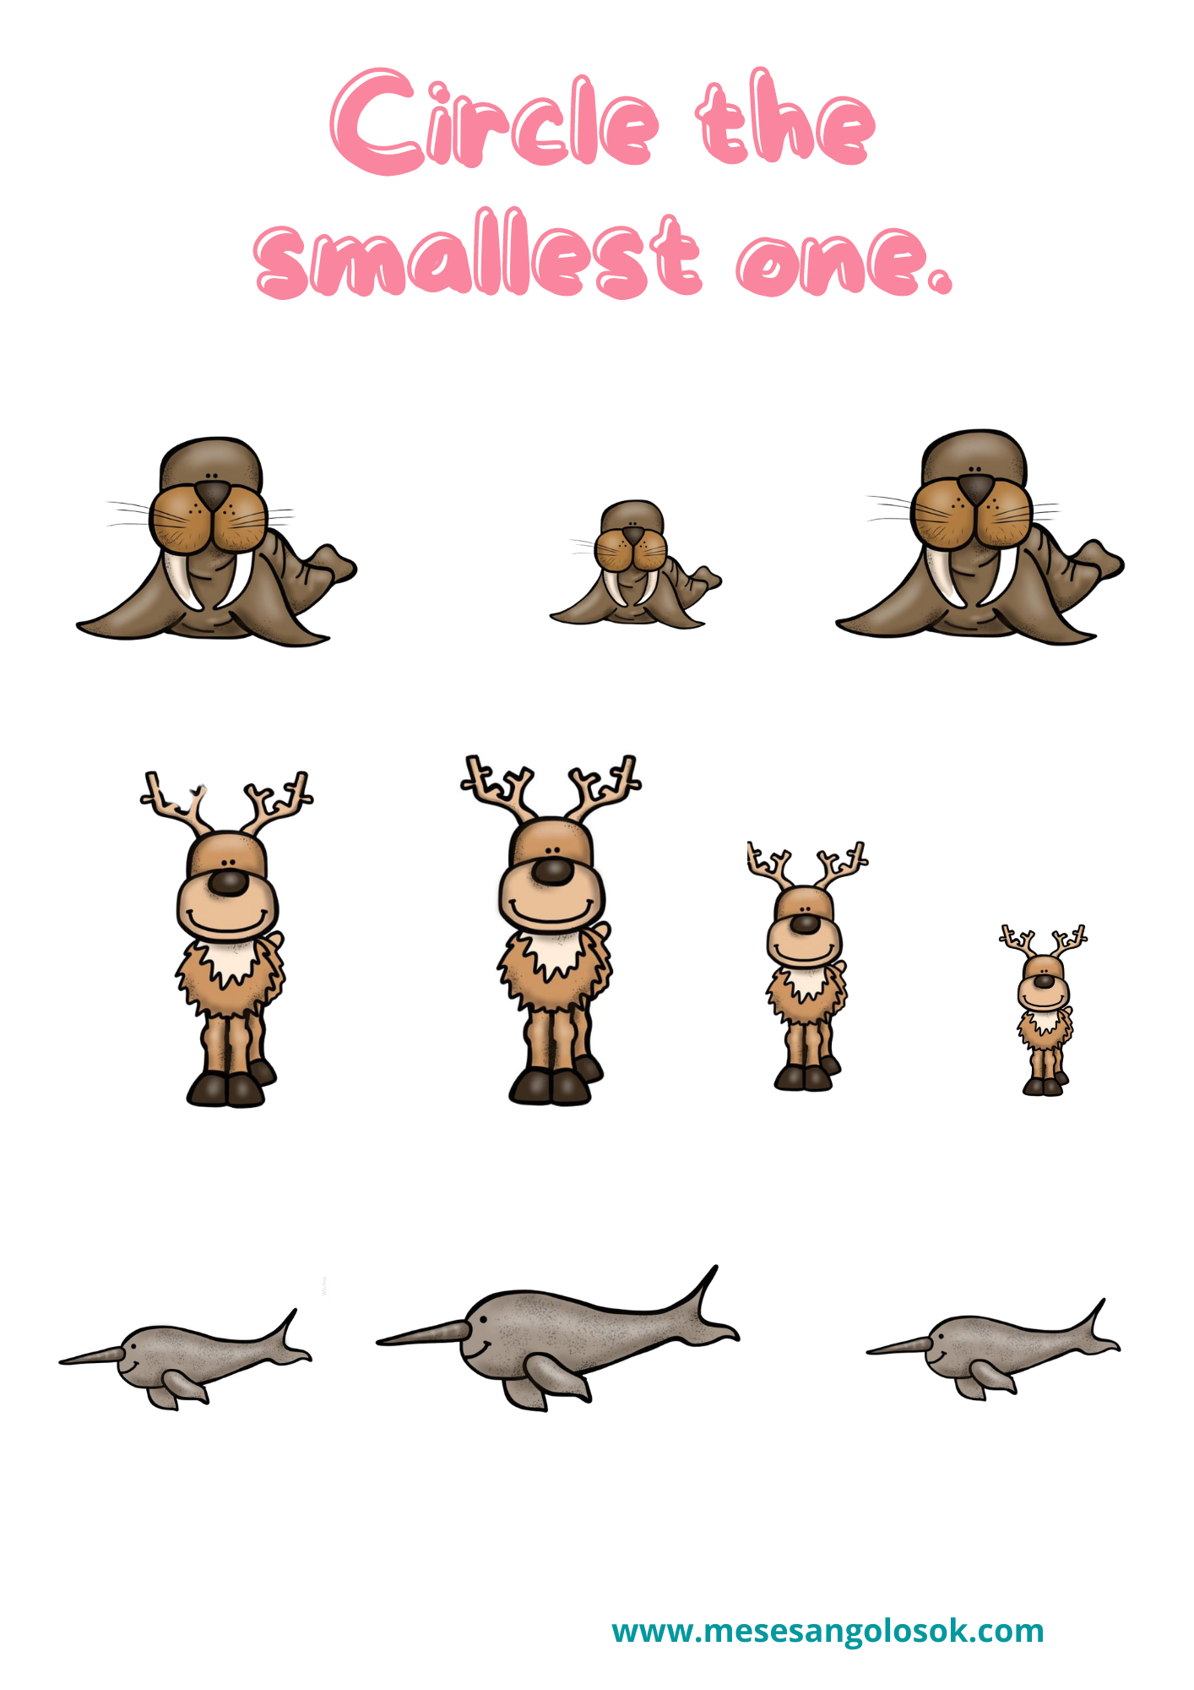

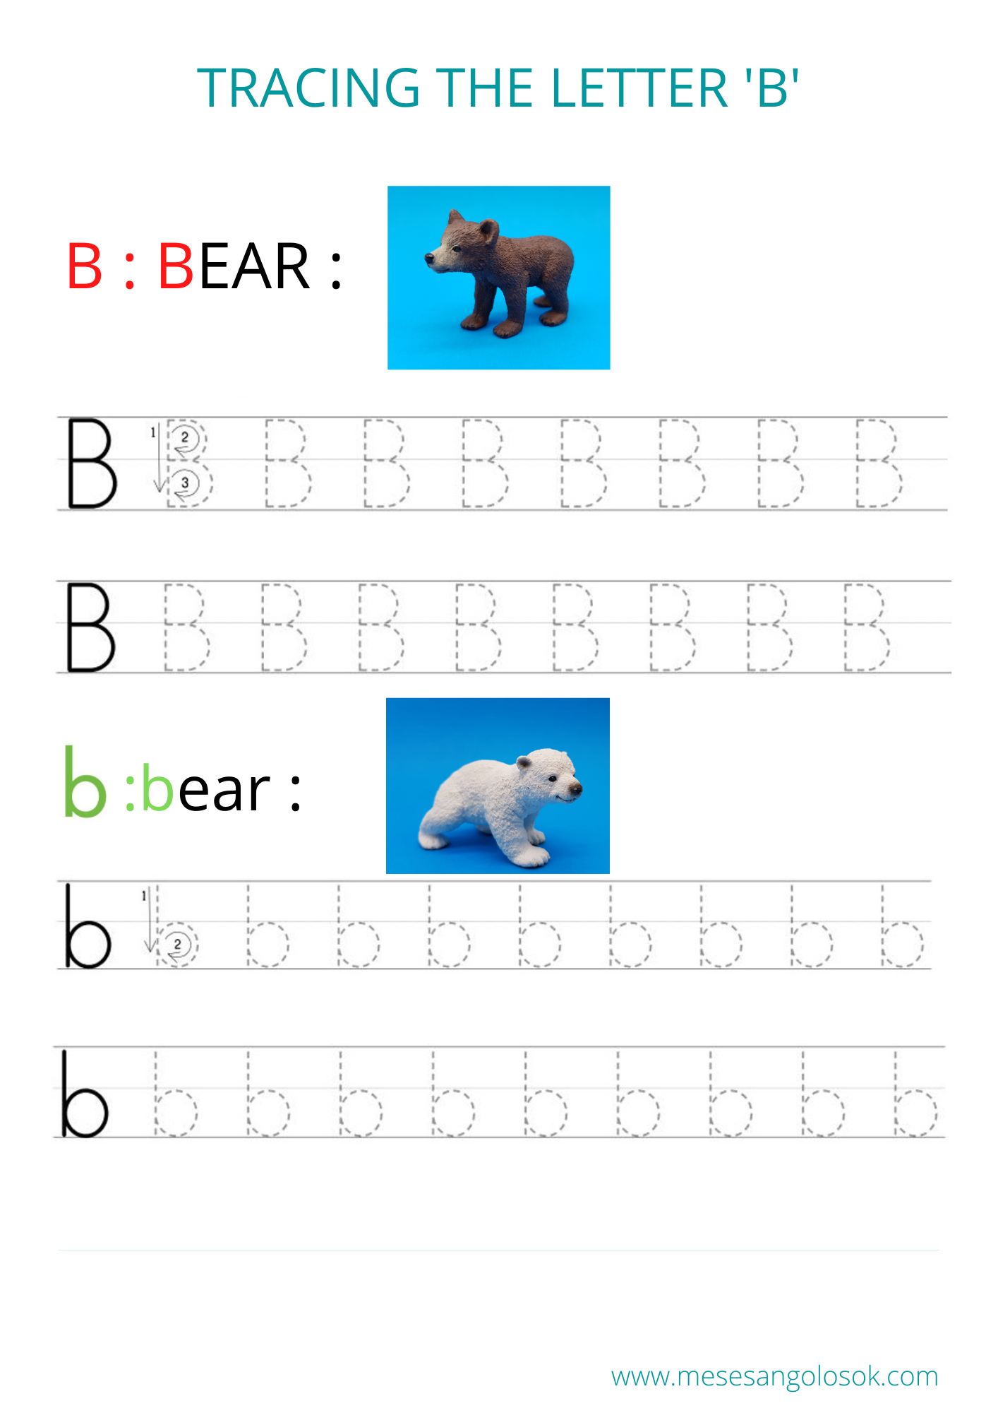

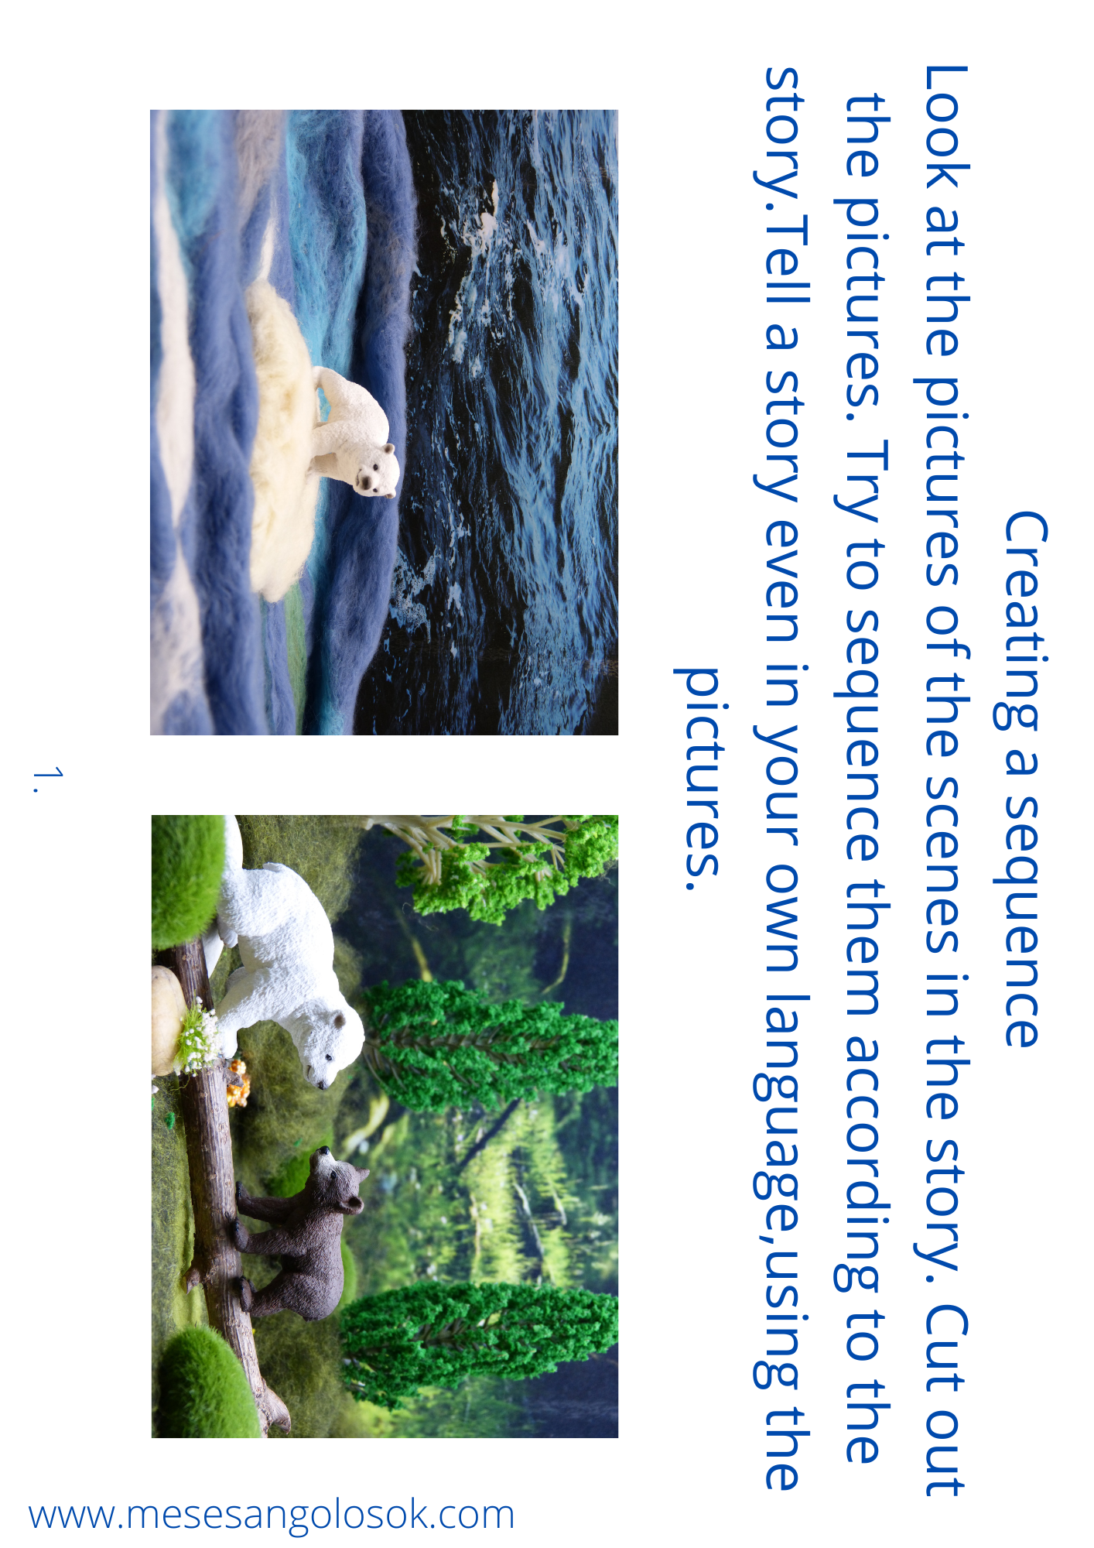

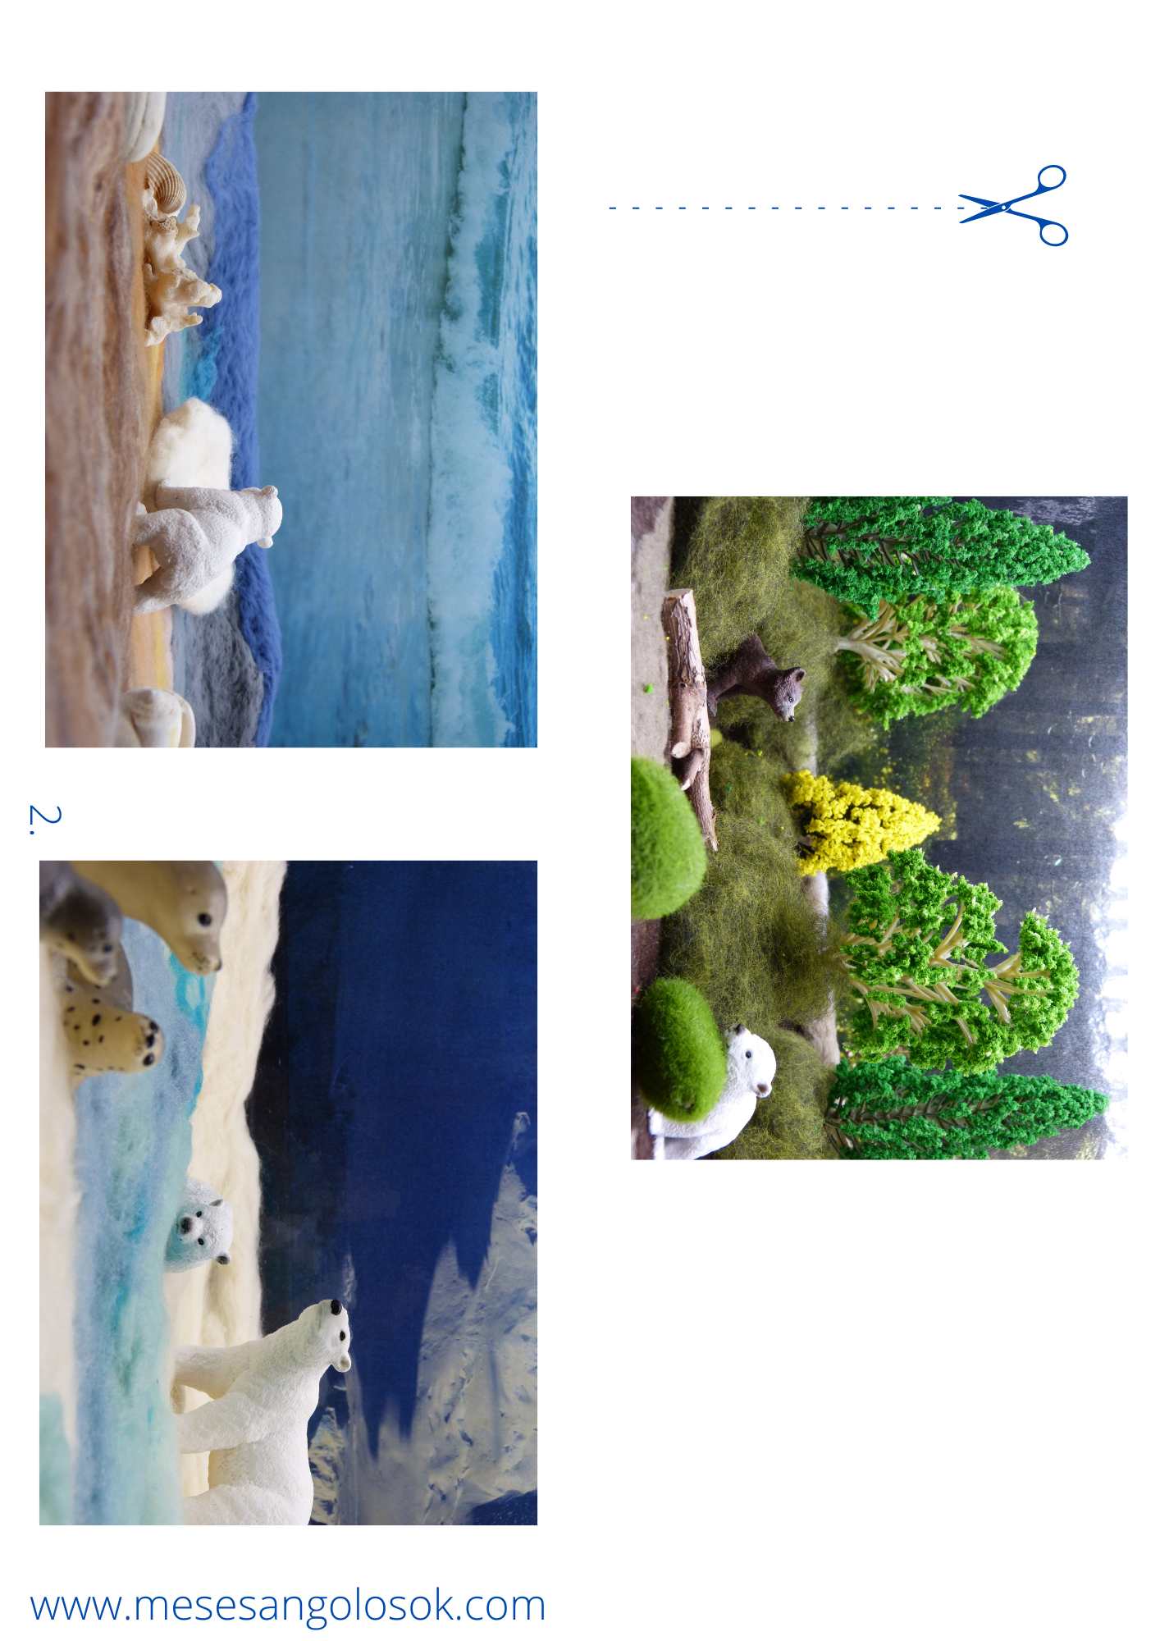

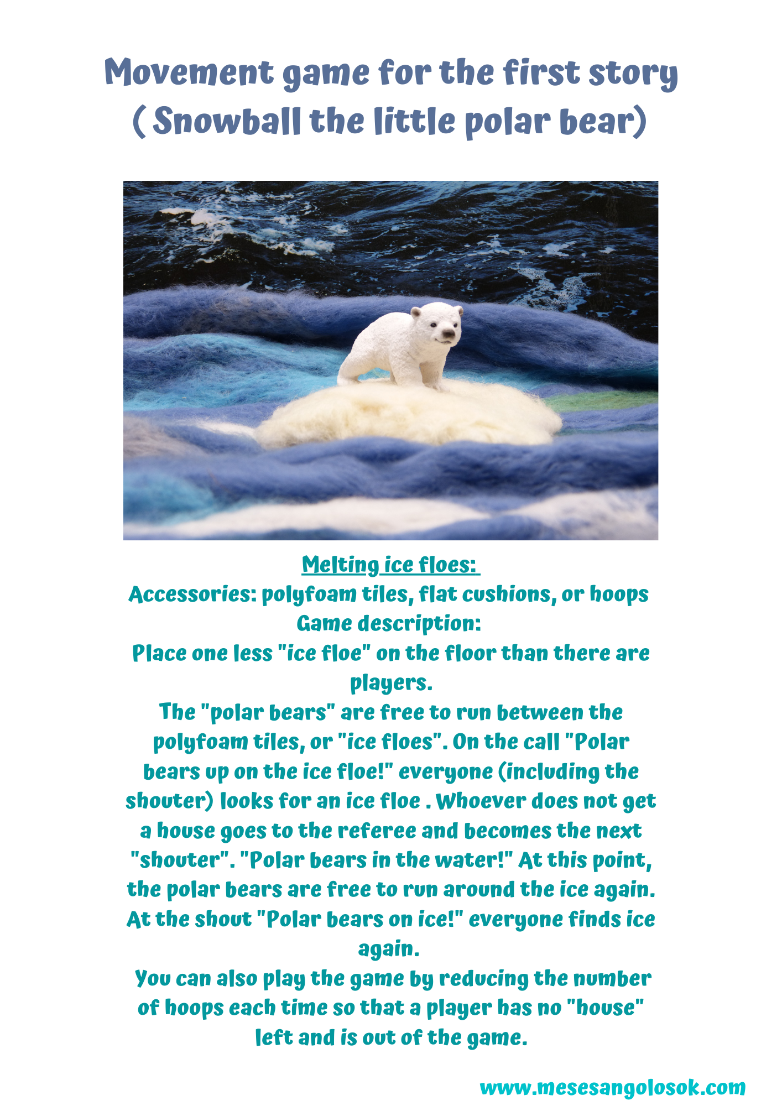
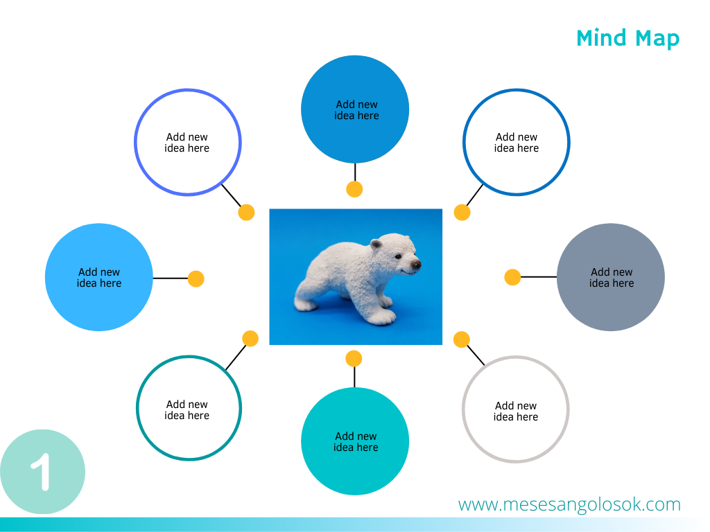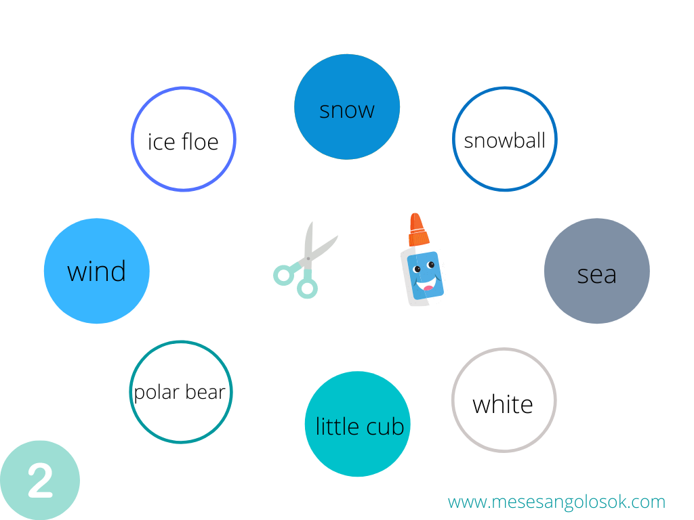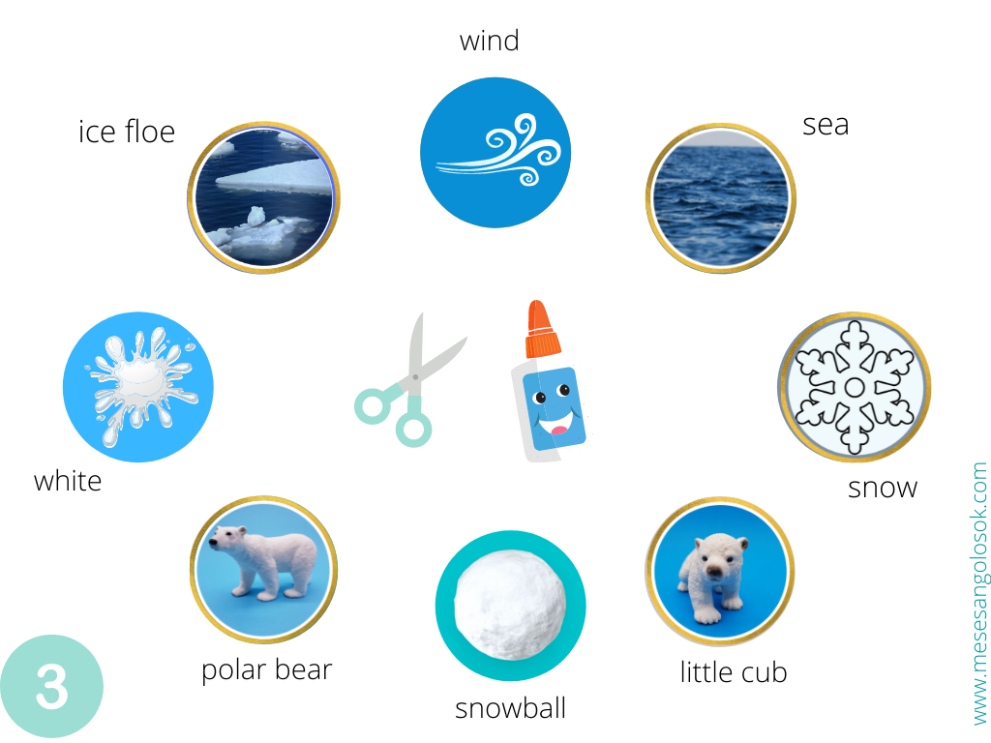

Congratulations!You have reached the end of the first lesson!

